- Introduction
Abstract: One of the main applications to statistical analysis is that of quality control. Quality control is a set of statistical procedures used to maintain consistency in the products being produced. The two primary methodology of quality control comes from Acceptance Sampling and that of Control Charts. This paper explains these two methods of quality control and applies it to quality control on the SECOM dataset for semconductor manufacturing by exploring further topics such as PCA and ARIMA plotting as well as an in-depth exploration of the ZIP procedure for quality control.
Part I: Statistical Quality Control
Ia: Acceptance Sampling: Acceptance sampling is based on the concept of the operating characteristic curve. With such, we have different characteristics available here including the OCC – Operating Characteristic Curve. The basis of the OCC – Operating Characteristic Curve – comes from the goal of producing a graphical representation of what constitutes as an acceptable quality level and what constitutes as a rejectable quality level. Some of the elements worth evaluating in the rejectable quality level include +

Single Sampling Plan for Attributes

Producer’s and Consumer’s Risk
(4/30/2022)
We have two different types of risks (alpha signifying producer’s risk) and (beta signifying consumer’s risk).
Ib: Control Charts: Control charts are designed to plot manufacturing processes and determine which processes are under control and out of control. The basic parts of any control chart consists of three variables – Control Chart at Center Line (CL), Upper Control Limit (UCL), and Lower Control Limit (LCL).
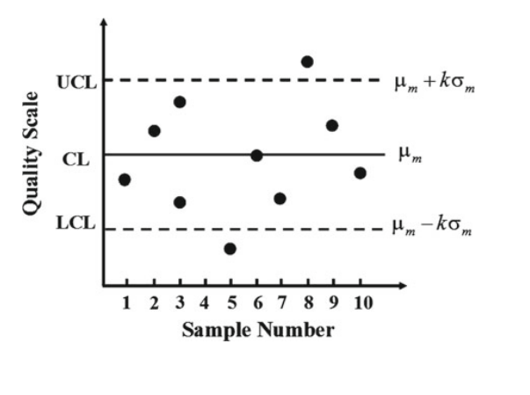
CL = E(R_i) = d_2 * sigma
UCL = E(R_i) + 3
u_(beta/2) = u_0.025
The conditions that lead a process to be out of control include when 1) A point falls outside any of the control limits 2) Eight consecutive points fall within 3*sigma limits 3) Two of the three consecutive points fall beyond 2*sigma limits 4) Four out of five consecutive points fall beyond 1* sigma limits 5) Presence of upward or downward trend 6) Presence of cyclic trend (p368). One specific type of control chart we discuss here is the Shewhart Control Chart. Some of the characteristics of
Part II: SECOM data analysis
1b: The first additional technique from quality control that we need to analyze is that of the Principle Component analysis. Principle Component Analysis, or PCA, can be best understood as a linear algebra technique which allows for us to reduce the components to ones that explain the patterns. Given that the SECOM is huge (over 500 items), many of the components are insignificant given that the variance is already explained by the other components making these components redundant. Some of the aspects we notice is the large number of potentially useful components – to include components that explain at least 2% of the variance, we end up with six components while to include components that can explain at least 1% of the variance, we end up with twenty-two components. Principle components are useful for determining which features to select for plotting with acceptance sampling and control charts. Semiconductor manufacturing data is also time series in nature and here, we also present a time-based representation of one of the variables (the most principle among the components selected). An example could be the ARIMA model for trend in deposition rate

Semiconductors, which have a wide application in electronics, robotics, and automation systems, are commonly examined in terms of their economic effects in technology,
“Classification case, Anomaly Detection for Detecting Defected Manufactured Semi-Conductors. Inventions aim to make human life easier and better. The ambition for the innovation and more advanced creates new ideas and inventions as the brand-new creation becomes primitive by time.

However, the most astonishing developments have been accomplished by scientists in the last century. One of the widespread advances in daily life is electronics and automation which makes our lives better life easier than ever. The first observation of the existence of semiconductors was in 1821 by Thomas Johann Seebeck. Nevertheless, until the discovery of the electron by J. J. Thompson in 1897, electric concepts of physics have not figured in detail. Josef Weiss, the first man who defined the “halbleiter” term which is the semiconductor in modern meaning in his Ph. D. thesis in 1910. In simple terms, a semiconductor is a material which acts as an insulator; however, it can behave like a conductor when it is combined with other materials like glass or by changing temperature. It is widely used in electronics to produce diodes, transistors, photo resistors and digital integrated circuits due to the differences available here that need to be considered in its regulable resistivity features.
Semiconductor production consists of three main stages of processes. The first one is the design process, the semiconductors are designed via highly sophisticated computers and required software tools. The second one is semiconductor machinery process, where the front-end and back-end manufacturing methods are applied. That parallels with back front-end fabrication; in this part, the semiconductors are settled on silicon wafers with the shape of the semiconductors being given by some special methods which are applied to processes such as in etching, photolithography or materials depositing. (Platzer & Sergant, 2016, p. 10). The last one is obtaining the desired materials through extractive metallurgy.
Firstly, designing and casting of semiconductors creates many expenses and it comes to the front with the manufacturing processes. This processes, can be assumed as the most expensive part. The semiconductor machinery part especially includes a special automation system which increases the cost significantly. The following process also costs a lot as the process mainly stands on physical power to give the shape to the material. The last process of the production is Back-end Assembly, tests and package processes. However, these processes are easy to operate, cheap and also crucial because of the fact that it includes the testing process.

Secondly, the wafers are separated from the semiconductors and the semiconductors become ready to be tested, after the tests packaged semiconductors take their places in autonomous systems and this is what makes it cheaper. One of the things that needs to be addressed is that the test process is quite swift and applicable and the package process is almost the same way. Packaging process and the tests are made throughout at this point in how knowledge is itself in the market (Platzer & Sergant, 2016, p.?)
Regarding the semiconductor production, its sale is to be able to have a proper recycling process of used materials. To begin with, the first thing to do for a recycling process is to gather the used materials, and the most common way of material aggregation is urban mining. Urban mining is to gather the valuable components from old products, buildings and wastes. It has a wide number of advantages like employment or environmental issues which makes urban mining quite popular in recent years (Namias, 2013, p. 29). With the general electronic waste types, semiconductors are the most used material in almost in every electronic device. The method of urban mining is quite beneficial in many aspects. It brings serious employment opportunities and decreases the expenses to handle the electronic wastes in city centers or buildings. The pre-processing is the second part of the recycle. The pre-processing of the metal recycling is crucial since the metal components are generally embedded in other materials or they are alloyed with some other worthless materials. Recognition of the materials and separation of them should be made properly so as to have a good recycling performance.

Lastly, there are a variety of methods to properly obtain the desired materials and this process is mainly called extractive metallurgy. According to Namias, extractive metallurgy consists of three main different processes. The first one is Pyrometallurgical processing and it is simply to melt the electronic wastes in high temperature furnaces. The second one is Hydrometallurgical processing which consists of chemical processes like acidic resolution and it became more popular than the Pyrometallurgical method. The last one is the Biotallurgical process. This process benefits from some microbes having interaction with metals and separate them from each other (2013, pp. 32-37). Three extractive metallurgy methods are significant processes to end the recycling. The characteristics of the methods can be chosen with respect to the expenses that might occur. The good recycle has always been significant to provide profitable production.
Areas to investigate include applying products of communication before we consider the wafer fabrication process. In this project we propose machine learning techniques to automatically generate an accurate predictive model to predict equipment faults during the wafer fabrication process of the semiconductor industries.
- Faults detection of the semiconductor process and simplified
“Aim(ing) at constructing a decision model to detect as quickly as possible any equipment faults in order to maintain high process yields in manufacturing” (Ozturk, 2018),the fundamentals of the manufacturing process with applications of the manufacturing processes and utilization of quality control strategies regarding the manufacturing technology. Semiconductor manufacturing process is a highly technically intensive field that requires careful analysis. In this paper, we acknowledge the semiconductor analysis that we need to actualize before we provide an evaluation of the quality control using the semiconductor manufacturing statistical modeling techniques such as PCA. In addition, the photolithography explanation of the systems involved is important as photolithography is the single most critical step to the process. As such, we can see that photolithography is useful in providing one of the major bottlenecks in quality control. Figure 1 below is an example of variance control using the 2-way PCA plots for variance control to describe data points we can see with the graphical representation issues here: investigating the two different ways of achieving the photolithography objective regarding the graph of the relationship between Index and the sum of the principal features using the photolithography machine include a graphical display of the data through principal component analysis.

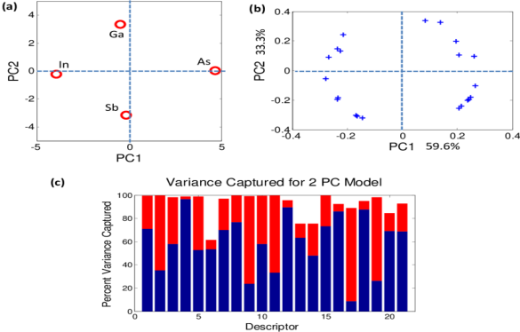
Figure 1 – Variance control

The following graph (figure 2) details the worldwide semiconductor revenues
described here. The red line deals with percent change in shares and the blue line
deals with total revenue between 1996 to 2021. This graph is related to quality control
as it shows how revenue has changed depending on the quality control methods used.

Figure 2: worldwide semiconductor revenues

How we analyze such involves both the quality control graphics as well as the theoretical underpinnings of how the device works, and the likelihood with the maximums. We are now involved in issues of semiconductor manufacturing technical design given the revenue increases as shown in the blue line as illustrated in figure 2 which also illustrates the worldwide semiconductor revenue issues for us to acknowledge the fault detection and recycling of materials in the manufacturing process described below for the fault detection systems.
3. Data Structure on Semiconductor – based PCA Manufacturing Methodology
Let us recognize what statistical systems are necessary when analyzing the semiconductor manufacturing process, which we will use principal component analysis procedures.

One method is to determine the PCA for the plotting, we use a time-based plotted graph. With such, time-plotting will figure out how errors are statistically arranged. We analyze the elements of three different characteristics of the semiconductor manufacturing data (Table 1) regarding the disparate analytical frames of the data.
To calculate the errors, we think about the differences of plotting options. We now look at the conflicting parts involved in PCA plotting and how charted EDAs can resolve these conflicts by determining unusual patterns within the dataset we will provide in the appendix II.
We look at the economic costs of manufacturing by segment of the procedure which we perform using PCA. The columns in table 1 include Manufacturing costs, Recycling, Global marketing of semiconductors.

Table 1:
Manufacturing Costs | Recycle | Global Marketing
Raw Material Preparation | Urban Mining | Industry Budgets
Designing and Casting the Semiconductors | Pre-processing | Marketing budgets
Black-End Assembly and Test | Extractive Metallurgy | Manufacturing budgets

In table 2, we have manufactured products including Oxidation, Photolithography, and Etching.
Table 2:
Oxidation | Photolithography | Etching
Thermal oxidation process | DUV | Wet Chemical Etching
Oxide quality | EUV | Dry Etching

Considering the inherent nature approach, we now look at the features means extracted from the semiconductor data (Appendix 1) before we apply the PCA Methodology for Quality Control analysis. As we can see in the data table below, certain features are accentuated including feature 1, feature 2, and feature 3 of which are given summary statistics regarding their distribution, evaluating semiconductor manufacturing and designing with PCA methods (Feature means table). We now need to think about the rationale behind the different ways with which we could consider the ways with which things are applied to the scenario. Some of the area

For the most part, the missing values are relatively low (less than 10%). However, in certain scenarios as described in figure 3 below, the values can be high in that we have some
observational values that are within the scope of the question involved. The observation indices describe the range of values possible – as we can see, there are more points in the higher range of the around 1500 that holds a very high percentage close to 0.25% of the time.
Feature means table 3
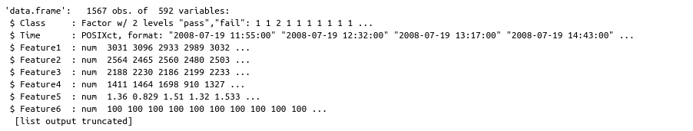
So, the feature means data need to be scaled. Our goal is to create an option through the PCA data analysis – the different means we can do with a prop table. Some of these matters (Table 3) include how we do the pca analysis. The different ways with which we can use include the feature as shown in the table 4 from 1 through 6 (a truncated set of 590 features.)
Table 4

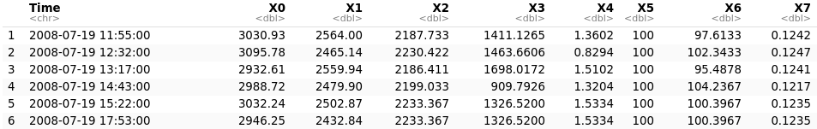

Now looking at the cities which are arranged on the plot below when analyzing the data and trend information within the trend data which is available in Appendix III.

Figure 3: Observation missing value percentage

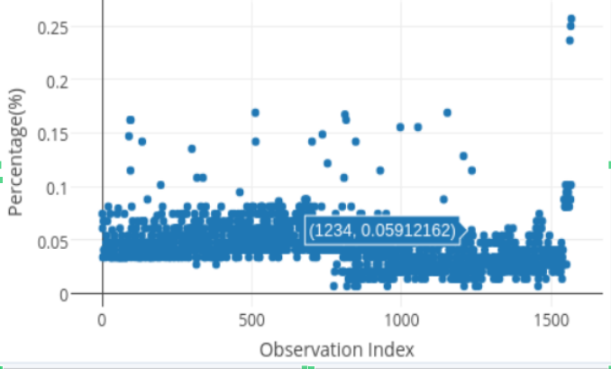

Plotting cluster package {ggfortify} supports cluster::clara, cluster::fanny, cluster::pam as well as cluster::silhouette classes. Because these instances should contain original data in its property, there is no need to describe the original data explicitly. (Figure 3)
What need to be analyzed include the different means with which we could think about the different parts of the procedure. One aspect of the procedure worth further elaboration is the plot from left to right - the X2 and X3 vectoral columns - come from the resolution of the questions involved here. One of the interesting aspects of the graphics we can apply to (Figure 4)
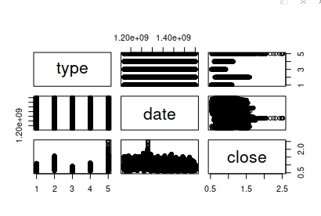

Figure 5 – datasets for the X_i’s for seventeen of the items.
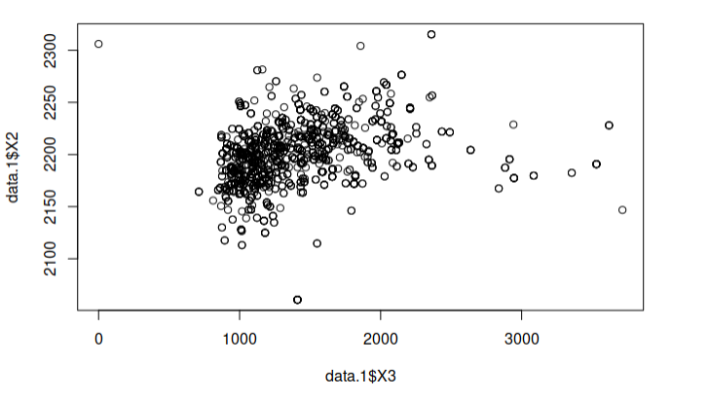
Figure 6 – scatterplot for data.1$X3

Figure 7 – data.1$X3 histogram plot

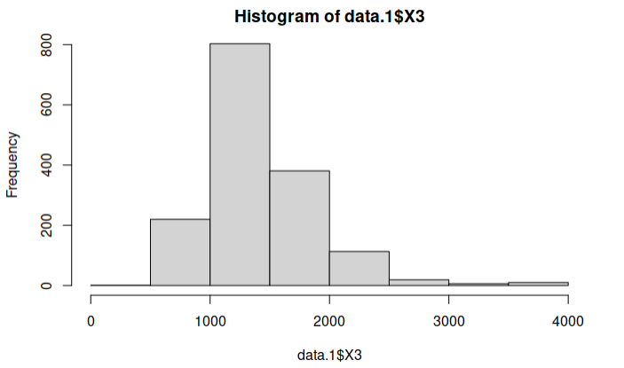

In Figure 6, we can now see from above that the different variants for us to construct a scatterplot that details the differences involved in the plot above which are necessary. What is a vector and how does vectors apply when making the analysis? The key element to vectorization comes from trying to determine the different sub-graphical elements explanation for semiconductors, we clearly need different indices. Some of these factors are useful when trying to describe general categorical metrics of a certain area. The plot shows a scatterplot of numerical objects. The points of contention within the plotting system in the different dimensions available are X1, X2, X3, X4, etc. Looking at the two factors available here for example, including factor1 - X0 (28.76) and factor2 – X1 (20.15), we see that these two factors are interesting when we analyze the conflicting interpretations available here. Furthermore, looking at the factor analysis percentages, we can see that the vector areas available here are themselves products of differences and analysis – When plotting the graphics as shown below in the vector chart, we see the three main dimensions of PCA plotting of X0, X1, and X3 that I can plot which allows for figure 8
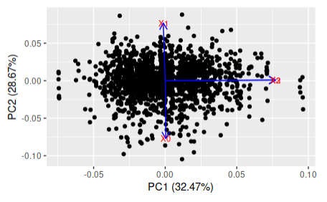
Figure 6 – PCA analysis using the dimension reduction
the pca analysis reduction procedures here. Continuing, to create the histogram of the na’s (not available data points) where we can see in the graph to be an even distribution. Worth noting is the large number of principal components – 589 in total – which means that the principal components can themselves be used to determine the different aspects before we are to analyze the differences here to the final components which is seventeen. For these reasons, we can apply the length function to determine the total number of NA’s in which from the list we have 1106 items (APPENDIX A). Furthermore, by measuring the proportion of NA’s to not-NA’s we have a decimal value of 0.7058073. With such, we can see that the decimal representation itself is a useful representation that can be represented using a proportional table – the proportions of true / false cases and the proportion of real/ not real cases. In such case, we can see the proportions as listed bellow we are to assign the median not available values. (Figure 8)
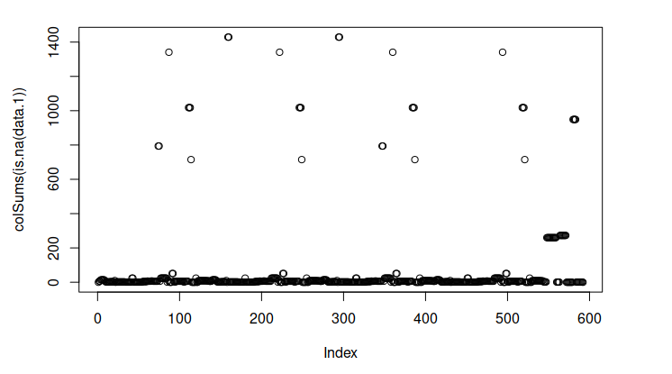

The indices available here from 0 – 600 is the means of analyzing this question as we are trying to determine the most important indices.
We can use new data as data 1 – different data from previous graph as detailed in the explanation over there. The means we can argue this question include how to design the accuracy, F1, specificity, precision and recall options.
Table 5 – PCA pass-fail rate for data 1
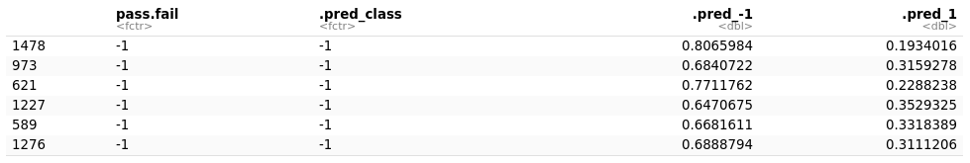
X3 is a histogram of the dataset
Furthermore, doing pca analysis using the two methods – random forest and decision tree – requires the following list of packages as described below. For example, the broom package, the dials package, the infer package, and the model data packages can be seen as prerequisites for making the distinguished elements easier to read and write about.
As described by Bourta in paper “Machine Learning for Sensor-Based Manufacturing Process”, the different regressive techniques present challenges by studying the applicability and the impact of the machine learning techniques for managing production processes considering the data from a semiconductor manufacturing process (SECOM dataset). In more details: (i) we have investigated the state of the art approaches for using machine learning techniques on the SECOM data set, (ii) we have cross compared three different algorithms for relevant features selection:: the Multivariate Adaptive Regression Spline (MARS) and the Principal Component Analysis (PCA)) and (iii) finally we have compared three sample classification algorithms (Logistic Regression (LR), Random Forest (RF) and Gradient Boosted Trees (GBT)). The evaluation of different algorithms have been performed using five metrics: the False Positive Rate (FPR), the precision, the recall, the F-measure and the accuracy.
The problem of incomplete data is the main topic of the current discussion. The data completion methods are derived from different types of classifiers such as the Decision Tree (DT), the Naı̈ve Bayes (NB) and the Nearest Neighbor (NN). The missing data is replaced so that it does not cause problems in classification. The causes that lead to missing values are various and they range from the cost of the acquisition to the timeliness aspect which is characterized by the unavailability of the data even if the data is obtainable. A common approach that is used for the substituting of the missing values is the use of the mean or of the mode. Even if the SECOM dataset is very imbalanced compared to the other datasets that are used in the experiments, when the data is classified using the Naı̈ve Bayes, both classes are evenly predicted.

The objective of Cross Validation is to split the data in order to estimate the performance of the tested algorithm. A part of the data (training) is used for training the algorithms while the remaining part (validation) is used for estimating the performance of the algorithms. For Cross Validation, we have used a 5-fold approach in which the data is split randomly in 5 subsets that have the same number of samples. The steps described in the next subsections are repeated five times and each time the testing data will be one distinct fold from the set of the 5 folds and the training data will consist of the remaining 4 folds. The training data is processed further in the sampling phase and the classification algorithm phase. The obtained model is evaluated using the testing data and the following metrics: the accuracy, the F-measure, the recall, the precision and the False Positive Rate (FPR). The experimental results are detailed in Section IV.

Sampling for PCA analysis testing
The objective of the Sampling phase is to treat the imbalance problem between the samples of the minority class and the samples of the majority class. Out of the 1567 samples from the SECOM dataset, 104 are fails and 1463 are passes. There is an evident imbalance between the fails and the passes. The imbalance ratio is approximately 1 : 14 (see Figure 8). The sampling is performed on the samples from the majority training dataset. The testing dataset is left unchanged in order to avoid problems such as overfitting. The first approach for improving the imbalance ratio is the random Undersampling of the Majority Class. “The number of instances of the majority class becomes equal with the number of instances of the minority class. The filter used in the undersampling is the SpreadSubsample filter from WEKA. The second approach is the Oversampling of the Minority Class.” The oversampling of the minority class is realized by using the Synthetic Minority Oversampling Technique (SMOTE). The SMOTE filter is applied several times until the dataset is balanced. After the oversampling of the minority class, the order of the samples is randomized in order to avoid the overfitting. `

In this research paper we studied and analyzed machine learning pca techniques that can be applied on the “datasets that are characterized by noisiness, high-dimensional feature space and imbalance in classification.” The dataset used in the experiments is the pca-applied SECOM dataset.
The contributions of this research paper are the critical study of the literature approaches that use the SECOM dataset as experimental support, the selection of the features using two new algorithms that were not used in the other approaches that study the SECOM dataset, the MARS and the Boruta algorithms, and the classification of the data using two ensemble methods from Apache Spark, the Gradient-Boosted Trees (GBT) and the Random Forest (RF). “The original dataset was oversampled and undersampled using the WEKA software and the final model was evaluated using five metrics: the False Positive Rate (FPR), the precision, the recall, the F-measure and the accuracy. Under the proposed configuration, the experimental results show that the best model is obtained when the majority class is undersampled, the features are selected using the Boruta algorithm and the data is classified using the RF algorithm.”

SECOM dataset is generated by a semiconductor manufacturing process consisting of more than one hundred steps and it is representative for a larger class of modern sensor based manufacturing processes. The final products that are the outcomes of the manufacturing process might fail the tests if there are defects which occur in the process. “The quality of the products, the increase of the equipment uptime, and the reliability are crucial and they can be improved by using appropriate classification techniques. The dataset consists of features or variables which are collected from sensors installed on process measurement, points and contains both useful information and irrelevant information such as noise or constant values. The number of samples is 1567 and each sample has 591 features”. Each test point is associated with a data timestamp and is labeled with 1 to indicate a fail and −1 to indicate a pass. The null values are described using ’NaN’.

The SECOM dataset for studying the impact of the three major problems related to the analysis of the data generated by hundreds of signals or sensors that is used for quality control. “The first major problem is represented by the selection of the most representative features that characterize the measurement data by taking into consideration the possible drawbacks that might exist such as the large number of features or signals, the existence of noise and the presence of irrelevant information. The second major problem is represented by the
imbalance between the pass and the fail cases considering that each measurement point is characterized by either a pass or a fail. The third major problem is represented by the selection
of the best classification algorithm.”

Furthermore, we are using several approaches for the selection of the features such as the removal of the features which have constant values and the removal of the features which have many missing values, examples including the Principal Component Analysis (PCA) and the Gain Ratio (GR). The tested algorithms is the k-Nearest Neighbor (k-NN), the Logistic Regression (LR), and the Decision Trees (DT). The metrics which are used to assess the performance of the model are the precision, the F-measure, and the False Positive Rate (FPR). The selection of the features is realized using the WEKA software, a machine learning workbench which supports many features such as data pre-processing, classifi-cation, clustering, attribute selection and data visualization. The predictive models for the detection of the equipment fault in the semiconductor manufacturing processes consist of several steps which are applied on the SECOM dataset such as: the data preparation, the data cleansing, the features scaling, the features reduction, the features selection, the variable component analysis, and the model selection. Considering the problem of data imbalances which occur in the pass or fail cases, various techniques such as decision trees and random forests are studied.
The Synthetic Minority Oversampling Technique (SMOTE) is the proposed method for the solving of the data imbalance problem. The imbalance between the pass and the fail class is solved by oversampling the fail class. The four algorithms which are compared are Random Forest (RF), ZIP, Artificial Neural Network (ANN), Logistic Regression (LR) and Decision Tree
(DT) will be discussed in detail below. The problem of incomplete data is the main topic of the study. The data completion methods are derived from different types of classifiers such as the Decision Tree (DT), the Naı̈ve Bayes (NB), and the Nearest Neighbor (NN). The missing data is replaced so that it does not cause problems in classification.

The causes that lead to missing values are various and they range from the cost of the acquisition to the timeliness aspect which is characterized by the unavailability of the data even if the data is obtainable. A common approach that is used for the substituting of the missing values is the use of the mean or of the mode. Even if the SECOM dataset is very imbalanced compared to the other datasets that are used in the experiments, when the data is classified using the Naı̈ve Bayes, both classes are evenly predicted.
While PCA is useful for reducing components, the final analysis is done using the ZIP methodology to determine the calculations,
The things that are necessary to consider before we recognize the different areas of analysis available here – additional method available here.
ZIP MODELING LAMBERT A TYPE
Our goal with ZIP modeling is to think about the different areas that are necessary to consider
This log-likelihood is easy to maximize, because L_c(lambda; y, z) and L_c(beta; y, z) can be maximized separately,
This log-likelihood is easy to maximize, because L_c(lambda; y, z) and L_c(beta, y, z) can be maximized separately.
With the EM algorithm, the incomplete log-like-lihood (3) is maximized and we look at the Simulation Experiments. LaTeX is another element worth noting when
To explore whether the asymptotic results pertain to finite samples, three simulations with 2000 runs each were carried out in S (Becker, Chambers, and Wilks 1988).
In the first experiment, n = 25, in the second n = 50, and in the third n = 100. Throughout, there is one covariate x taking on n uniformly spaced values between – and 1, gamma = (-1.5, 2), and beta = (1.5, 2), so tao = 1. With these choices, the Poisson means lambda range from .6 to 4.5 with a median of 1.6, and, on average, 50% of the responses y_i are 0 and 23% of the zeros are Poisson. The response y was obtained by first generating a uniform (0, 1) random vector U of length n and then assigning y_i = 0 if U_i <= p_i

L(beta, tao; y) = sum(log(e^-taoB_ibeta + exp(-e^b_ibeta))
+ (y_iB_ibeta – e^B_ibeta)
- sum(log(1 + e^tao B_i beta)
Looking at only runs
E(Y) = mu improves or degrades when a level of a factor increases both p and lambda. Similarly, it is hard to predict how mu changes when lambda and beta change, because no transformation of mu is linear in both gamma and beta. The same difficulty arises in interpreting fixed coefficients in log-linear models with random effects.

4.1 The Simulation Experiments
To explore whether the asymptotic results pertain to finite samples, three simulations with 2,000 runs each were carried out in S (Becker, Chambers, and Wilks 1988). In the first experiment, n = 25, in the second n = 50, and in the third n = 100. Throughout, there is one covariate x taking on n uniformly spaced values between 0 and 1, lambda = (-1.5, 2), and beta = (1.5, 2), so tao = 1. With these choices, the Poisson means lambda range from .6 to 4.5 with a median of 1.6, and, on average, 50% of the responses y_i are 0 and 23% of the zeros are Poisson. The response y was obtained by first generating a uniform (0, 1) random vector U of length n and then assigning y_i = 0 if U_i <= p_i and y_i ~ Poisson (lambda_i), otherwise.
The response y was obtained by first generating a uniform (0, 1) random vector U of length n and then assigning y_i = 9 if U_i <= p_i and y_i ~ Poisson(lambda_i), otherwise.
ZIP and ZIP(tao) MLE’s and likelihood ratio intervals were found by the Newton-Raphson algorithm
ZIP (tao) Regression. With such, we need to think about the ways
#Zero counts in Always-0 group
P(Y_i = 0|x_i, z_i) =
Then, mixed probabilities for ZIP are expressed as follows:
Figure 5. Estimated Probabilities Compared to Empirical Probabilities for the Manufacturing Experiment. In each case,
ZIP (Tao) Regression
Since the factor levels in the fitted model (5) that improve lambda generally tend to improve p as well, it is reasonable to fit ZIP(Tao) regressions to the printed-wiring-board data. Table 6 summarizes the fits of several ZIP(Tao) models. The model
I = [I_1 I_2]
[I_3 I_4]
Observed information can be substituted for expected information in the asymptotic distribution. If () maximizes the log-likelihood (3) under a null hypothesis H_0 of dimension q_0 and () maximizes the log-likelihood (3) under a nested alternative hypothesis H of dimension q > q_0, then we can think about the differences that are necessary to consider before we analyze the
I = [I_1 I_2 I_3 I_4]
We need to think about the different ways

When the Poisson regression model is applied to the count outcome data in real world, it is not rare to see the poor model fit indicated by a deviance or Pearson’s chi-square. Most of the real data violate the assumption of the standard Poisson model, which is called ‘equidispersion’. The Poisson regression assumes that the variance of the count outcome is equal to the mean, whereas most of the real data have a greater variance than the mean. This is usually referred to as ‘overdispersion’. Ignoring overdispersion and applying the standard Poisson regression for this data can cause underestimation of standard errors and p-values, therefore increasing the chance of an inflated Type I error. The zero-inflated Poisson (ZIP) is an alternative that can be considered here. This model allows for overdispersion assuming that there are two different types of individuals in the data: (1) Those who have a zero count with a probability of 1 (Always-0 group), and (2) those who have counts predicted by the standard Poisson (Not always-0 group). Observed zero could be from either group, and if the zero is from the Always-0 group, it indicates that the observation is free from the probability of having a positive outcome (Long 1997). The overall model is a mixture of the probabilities from the two groups, which allows for both the overdispersion and excess zeros that cannot be predicted by the standard Poisson model.
Limitations:
5/3/2022
The basis for the paper comes in from the desire to explore the different means with which we can apply quality control methodology to real life data such as that of the SECOM data for quality control. While we have done an in-depth analysis of the ZIP methodology, other methods such as Time Series ARIMA and PCA can be explored in further depth. Some of the matters that we need to look at include the ARWA diagrams available here.
Phase I estimated parameters from the simulated data X. Because of this reason, we need to look at the different ways with which we could deal with the issues here. Some of the questions worth asking include dealing with the difficult cases available here. Some of the issues that need to be considered include
SPC
nrep = 1000
Conclusions
library(spc)
xewma.crit(l = .05, L0=250.8, mu0 = 0, sided
Appendix I

Appendix II

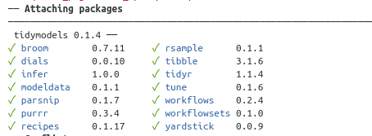

References:
file:///home/ken/Downloads/Semiconductors%20(4).pdf
“Machine Learning for Sensor-Based Manufacturing Process”.

We need to start thinking about the different means with which we could analyze the different aspects including process and technical design methodologies.
EDAs refers to

